Process Specification
for the
Auditory MMO Project

By

Ryan Braun
Michael Jenkins
Matthew Garber
Robert Davis

of
Team DarkDev

PROJ-D1-DarkDev-Spring2011

As of: 2 February 2011
Introduction
For our project, we have decided to use the spiral model development process. It is the consensus of the team that while developing the massively-multiplayer online game many functional prototypes will be developed and the project will need to go through numerous iterations, assessing risk throughout. This project has a high degree of risk attributed to it and will have to be monitored thoroughly to ensure completion. Incorporating the risk discovery phase presented in the spiral model process will allow our team to reformulate possible extraneous project goals and focus on a desired deliverable.

Tasks
Primary
- Determine educational element of project.
- Create network architecture/infrastructure.
- Define game mechanics.
- Create a user modification interface.
- Develop game storyline including character scripts.
- Develop an interpersonal communication system.

Secondary
- Calibrate items to have an exponential growth in power.
- Design a visual interface.
- Make sound development choices including voice-acting, sound effects, and music.

Roles
- Client – The client will provide business rules and requirements. The clients will also be accepting each phase as the project moves forward.

- Students/Users – The User is the person that will operate the software. The users will help with requirements gathering and testing.

- Requirements Analyst – The Requirements Analyst Team will work through the given requirements and any unforeseen requirements to aid in the development of concept and in each prototype and iteration thereafter.

- Software Engineer – The Software Engineering Team will be responsible for taking the prototypes and concepts and implementing them within the software system itself.

- Architecture Engineer – The Architecture Engineering Team will be responsible for the design and implementation of the Architecture System that best fits the project needs.

- Audio and Graphic Engineer - The Audio and Graphic Engineering Team will be responsible for the designing, recording/producing, editing, and implementation of the audio and graphical files into the system.

- Developer/Programmer – The Developer(s)/Programmer(s) will be responsible for the coding of the concepts and designs produced by the Software Engineering team. This group must work very closely with each of the engineers in the project to maintain a function software product.

- Storyline/script Developer – The Storyline and Script Developer will be responsible for plot and character creation and requisite dialog.

- Tester – This group will be made up from many areas. It will include students, project team members, outside developers, the client, and many others. This area is one of the most important elements to the project and must be done very strategically.

- Documenter – This group will be responsible for Document Creation, Document Maintenance, and Status Updates throughout the project.

Phases
- Develop a concept of requirements
Based on knowledge of the project and meetings with the customer, a concept of the requirements will be developed.
- Develop a concept of operation
Based on the concept of the customers’ requirements, develop a methodology for handling iterations of the process model.
- Requirements plan
Review the requirements and formulate a plan, identifying and resolving risk prior to constructing the first prototype.
- Develop prototype 1
Based on the plan and individual member’s roles divide up the prototype deliverables and construct a paper prototype that satisfies the requirements list.
- Requirements gathering
After allowing the customer to review prototype 1 elicit further requirements from the customer including features that were not incorporated in prototype 1.
- Verification and Validation
Confer with the customer to ensure requirements are met by the next prototype.
- Development plan
Design a plan that will meet the goals of the customer and remove the weaknesses of the first prototype, identifying and resolving the risks involved.
- Develop prototype 2
Based on the plan and individual member’s roles divide up the prototype deliverables and construct a computerized prototype that satisfies the requirements list and accurately addresses risks identified by prototype 1.
- Develop a draft
After allowing the customer to review prototype 2 develop a final draft of the project that defines member’s roles and their scheduled deadlines along with a complete list of desired features.
- Verification and Validation
Confer with the customer to ensure requirements are met by the operational prototype.
- Develop a test plan
Devise a test plan to ensure features meet a specific level of quality.
- Develop the operational prototype
Based on the plan and individual member’s roles divide up the prototype deliverables and construct a prototype that satisfies the requirements list and accurately addresses risks identified by prototype 2.
- Develop a detailed design
After allowing the customer to review the operational prototype produce a detailed design of the final concept and features required for the project, identifying individual member’s responsibilities and their scheduled deadlines.
- Code
Using the operational prototype expand to reflect desired features, checking code integrity with unit testing.
- Integration
Integrate individual efforts performing validation testing to ensure program functionality across the network architecture.
- Test
Perform acceptance testing on the project to ensure customer’s requirements are met.
- Implementation
Distribute the project to individual schools and verify its functionality.

Communication Plan
Communication throughout the design and implementation of this project is going to be the key to success.

For the design phase of the project we have implemented the following schedule:

Team Meetings:
Monday 5:45 – 7:45 PM
Wednesday 5:45 – 7:45 PM (If necessary)
Friday 9:00 – 9:30 AM

Client Meetings:
Friday 9:30 – 10:30 AM

The client has also agreed that additional meetings can be called with notice and schedule depending. The client has also agreed that e-mail communication will be utilized.

For the implementation phase of the project we will reevaluate the schedule and either proceed with the current schedule or make adjustments as necessary.

Scheduling
See attached Gantt chart

Peer Review

Individual Effort:
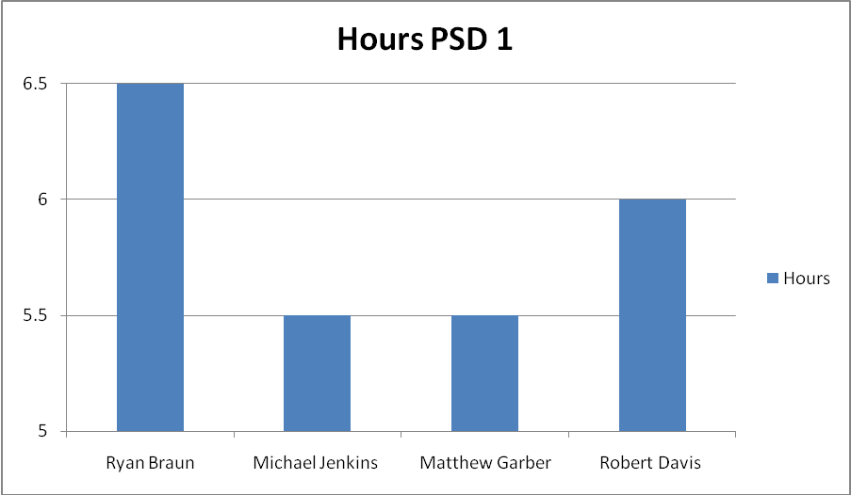
Meeting Minutes:
1/28/11
Base ideas:
- Modding is a major part of the game, but is not required for the game to run. What is required is a base that modding can be added to.
  - Modding can take place in a form of a database modification.
  - Modding can also be when they build their own town/environment and show off to other players. This town can also be a standalone wilderness.
  - The mods can be made on the school’s small servers then added to the game via a submission process.
    - This process checks to see if the mod is balanced, clear of profanity, and will run without bugs in it.
  - Schools may want to turn off mods for whatever reason.
- Visual aid in addition to sound, but the visual parts is a minimum and only used for if the player is lost or needs additional help.
- Violence needs to be a minimum for this game.
- Revision is a major part in developing.
  - Every feature needs to be calculated carefully so that they all work well for the seeing impaired.
- Testing
  - How the testing should be implemented
  - If we should get kids form the blind schools to test the game
- Should always keep in mind that this is for education purposes, not to make money on. The game should be fun to play above all else.
- Don’t worry about voice acting at the start of this project
  - We may get a group in to record all the voices for us, but this is still much further down the development line.
- We most likely will have to be stricter on rules then others due to the lack of full time people watching the game.
- In the storyline and in other parts, multiple paths the player can take would be good to add into the game.
  - This would also help teach the students about if statements.
Networking:
- Peer-peer server setup and client-server setup.
- This project will most likely be made up of both types of setups.
- The number of servers will most likely be one central server.
  - Possible secondary “buffer” server to go between the client and central server.
  - Possible mini-servers where the students can test, debug, and upload their mods onto the main server.
- The client will store assets that will be used from the central server via an upload mechanism.
- Voice chat will most likely be a good idea to add into the game.
Things to look at:
- Peer vs. peer play and peer vs. monster play.
  - Playing in a party and players playing the game by themselves.
  - Also about showing off their items in the game.
  - PvP needs to be controlled so over powered people will not face starting people.
  - Also with little or no risk to their character.
- The power of items and equipment will most likely need to be exponential in growth to increase the “addictiveness” of the game.
- Anonymity of each player.
  - Possible connecting to Facebook.
  - This may cause problems with parents and keeping the clients lives separate.
- Finding a game and looking at what it does well in comparison to other games.
  - These games can either be for the blind or for normal average people.
  - Do not re-invent the wheel idea.
- We can make the game open source.
  - The community cannot edit our code, but they can give us ideas or other input on how to make it better.
Education:
- We always must remember that this is to be used as an education tool.
- An idea to add education into the game is to have a programming requirement for ever level branch, like every 4-7 levels.
- Another idea was that a flag is marked if the player was in the programming class. This flag will add additional requirements for levels or may unlock unique items for the player.
Things for next meeting:
- Figure out a tangible budget for general use for the entire project.
- Make a basic prototype of the game to play for the next meeting. A paper prototype is an example of this.
Individual Responsibilities:
Introduction: Ryan
Tasks: Michael
Roles: Robert
Phases: Ryan
Communication Plan: Matthew
Scheduling: Michael and Ryan
Peer Review: All team members

Version Control Summary:
For this phase of the project, we are using e-mail for version control at this phase in the project.
Aggregate Estimated Effort to date

Individual effort:

Individual responsibilities:
Ryan
- Client Meeting (1 hour)
- Sound Recording (.5 hour)
- Spiral Model Research (1 hour)
- Prototype Development (2 hours)
- Introduction Development (.5 hour)
- Phases Development (2 hours)
- Review and Editing final draft (2 hours)
Michael
- Client Meeting (1 hour)
- Sound Recording (.5 hour)
- Meeting Minute write up (1 hour)
- Prototype Development (1 hours)
- Tasks Development (.5 hour)
- Spiral Model Research (1 hour)
- Review and Editing final draft (2 hours)
Matthew
- Client Meeting (1 hour)
- Sound Recording (.5 hour)
- Meeting Minute write up (1 hour)
- Communication Plan Development (1 hour)
- Spiral Model Research (1 hour)
- Review and Editing final draft (1.5 hours)
Robert
- Client Meeting (1 hour)
- Meeting Minute write up (1 hour)
- Roles Development (1 hour)
- Spiral Model Research (1.5 hour)
- Review and Editing final draft (1.5 hours)

Version Control Summary:

