Design and Plan Document
for the
Auditory MMO Project

By

Ryan Braun
Michael Jenkins
Matthew Garber
Robert Davis

of
Team DarkDev

PROJ-D3-DarkDev-Spring2011

As of: 24 March 2011

Introduction
This document outlines the design and plan for the auditory massively multiplayer online game project. It outlines the architecture description, the design description, the software process, the people involved, risk management strategies, required resources, and the project schedule.

Architecture Description

Create a Massive Multi-Player Online Gaming Architecture

Client Server Communication-
There are many challenges that present themselves from an architectural standpoint. The first challenge is designing the gaming environment to cover the minimum five cooperating school districts across the county. The challenges here lie in the network communication sector. The initial system design is designed around the SmartFoxServer 2X (SFS2X) Platform. SFS2X gives us out of the box API and Libraries for network communication.
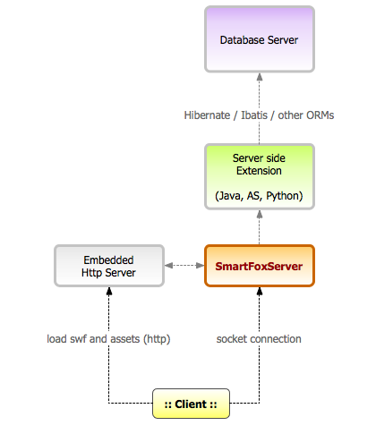
Taking a bird’s eye view at the SmartFoxServer 2X platform and briefly discuss each of the components in the stack. Starting at the core of the server we find the network engine (codename BitSwarm) which is the third incarnation of the original socket engine built for SmartFoxServer 1.x. This layer provides unique features to SFS2X that are typically not found in other competitor’s solutions. In essence BitSwarm provides TCP/UDP connectivity, Session management, network security tools, the HRC (High Reliable Connection) system, clustering services, monitoring and more, using an highly scalable non-blocking design.

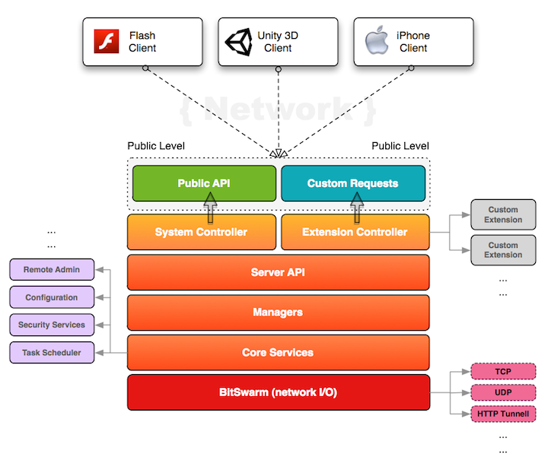
The next concept that we utilize from SFS2X is its use of Zones and Rooms. Zones and Rooms are what the game script will be based around and allow the client to listen and respond to data that is pertinent to that Room.
SmartFoxServer 2X introduces significant improvements in the way Zones and Rooms can be configured. In particular it established a new simple concept called Room Groups that allows organizing Rooms into logical groups, separated from each other’s. Users will be able to subscribe for events happening in the Groups they are interested in, ignoring all the others.
A major advantage of this approach is that the initial room list sent by the server will be smaller, and the number of events fired to each User is highly reduced, especially in case of high traffic applications.
Initial Room and Zone Layout

A User could initially subscribe to the Lobby group and receive Room updates (such as newly created or removed rooms, user count changes and RoomVariables updates) only for the Rooms under that Group. If the User is interested in playing games he can subscribe to one of the other game Groups, see which games are available and join them. Users can also unsubscribe any Group at any time.
The following list describes a few different possible scenarios:
- User joins the Zone without subscribing to any Room Group: in this case the user will receive an empty room list and won't be updated by the server about any Room event. This is a good setup when you want to let the User interact with your server-side Extension without having to receive unwanted Room updates etc... A typical use case is the User registration form, consulting a user-search functionality or other user-profile related activities where the interaction with other clients is not requested.
- User joins the Zone and subscribe to an initial Room Group: This is probably the most common use case The difference here is that the room list will contain only the Rooms in the selected Group and will filter out all the others. The client will be updated about newly created or removed rooms by default. The developer will also be able to configure other events such as the UserCount update, RoomVariables update etc...
- User joins the Zone and subscribe to multiple Room Groups: Subscribing to multiple Groups allow for a more sophisticated Room filtering. The player will be able to obtain a custom room list composed by the Rooms in the selected Groups. Typically the client will join a Lobby Group, maybe a Chat group with a specific theme and a Game group where he can look for games to play.
Finally Groups can be created at runtime and subscribed/unsubscribed dynamically.

Database Design –

The database is a critical part of our application. We will be using the following table design in the beginning of our implementation. The table design below is based on the storage of the Players (Users) information. As we move forward we plan to add a table hierarchy to represent the items, structures, enemies and monsters found within some “rooms”. The reason for moving to this implementation is to allow for dynamic modification to be made by the end user to these rooms. By designing the system in this manor users will be able to design their own rooms, including structures and enemies.

Initial Player Database Design

Game Design Engine
We have chosen to develop our project on the Unity3D Game Engine. Unity allows us to focus on game play by providing an incredibly powerful backend service. This allows us to simply write classes and functions and attach them to “Game Objects”, Unity then handles all hookups automatically. Unity also allows us flexibility with 3D Sound which is a large portion of our character control system.

Design Description
- See attached UML diagrams

Software Process
Our software process has been modified from a pure spiral process to include elements of the agile process model, specifically scrum development.

For this software process, three roles are defined: a product owner, who represents the customer; a ScrumMaster, who keeps the team focused, enforcing the scrum process rules; and a team, which is responsible for delivering the product. The product owner role has been assigned to Ryan Braun, the ScrumMaster role has been assigned to Michael Jenkins, and the team role consists of both Robert Davis and Matthew Garber.

We have followed our process model closely and through the use of the spiral model in developing an auditory massively multiplayer online game our process model and team member roles have evolved.

Platform availability
The platform we want to use to develop this project is the Unity game engine. Currently, it is unclear whether or not professional developer licenses will be provided to us free of charge. If we are unable to obtain the licenses we will seek partnerships to cover the cost.

Java bridge implementation
The Java Bridge is a component that will allow us to use the HOP Programming Language Tools and other Java Classes functionality inside of our application. One of the main requirements is that the game must be modifiable through the HOP Language. We currently have two distinct designs for the implementing this bridge. We will choose an implementation by April 18th, 2011. We will make our decision based on prototyping that is currently underway with both systems.
Design 1:
Game Application Side:
Bridge Class
Connect() – This function attempts to establish a connection to the HOP-Unity Bridge Application running locally.
Disconnect() – This function terminates the connection to the HOP Bridge Application.
ProcessEvent() – This function will process all messages received from the HOP Bridge. Each Message will be decoded as {String Message=”tag” + “Text”) whereas the tag determine how to process the Message and the Text is the Code, Command, or other information that will then be processed.
Send(string message) – This is the function that we will call to pass the message to the Bridge.

HOP-Unity Bridge Application:
Bridge Class
Start() – This function tells the application to begin listening for and processing messages.
ProcessEvent()-This function will process all messages received from the Game Bridge. Each Message will be decoded as {String Message=”tag” + “Text”) whereas the tag determine how to process the Message and the Text is the Code, Command, or other information that will then be processed.
An example of this would be Message = “HOP {Some Java Code}” . This would be the message that we would send to the HOP Bridge to process a piece of Java Code in HOP.
SendResponse(string message)-This function will pass a tag encoded message in Response to the ProcessEvent() function. In other words it will pass information back to the Game that resulting from processing the message that we just sent to the Bridge. This information could be text to display, commands to modify items in the database, etc.
Restart() – function Restarts the Bridge Application
Stop() - function Stops the Bridge Application

Design 2:
This design is based from a built in set of runtime classes in Unity. The idea is to use the “AndroidJNI”. This class structure was built inside of Unity to be able to use Java for Android application development, but Unity says that it can be used with any Java Code. We think this would be a better approach based on the amount of system resources that will be required to run both applications in Design 1. Also with this implementation there is actual not a “bridge” we are simply able to apply Java code to our project using the JNI functionality.
Design 2 Class Structure:

AndroidJNI

'Raw' JNI interface to Android Dalvik (Java) VM from Mono (CS/JS)
Class Functions
AttachCurrentThread | Attaches the current thread to a Java (Dalvik) VM.
DetachCurrentThread | Detaches the current thread from a Java (Dalvik) VM.
GetVersion | Returns the version of the native method interface.
FindClass | This function loads a locally-defined class.
FromReflectedMethod | Converts a java.lang.reflect.Method or java.lang.reflect.Constructor object to a method ID.
FromReflectedField | Converts a java.lang.reflect.Field to a field ID.
ToReflectedMethod | Converts a method ID derived from clazz to a java.lang.reflect.Method or java.lang.reflect.Constructor object.
ToReflectedField | Converts a field ID derived from cls to a java.lang.reflect.Field object.
GetSuperclass | If clazz represents any class other than the class Object, then this function returns the object that represents the superclass of the class specified by clazz.
IsAssignableFrom | Determines whether an object of clazz1 can be safely cast to clazz2.
Throw | Causes a java.lang.Throwable object to be thrown.
ThrowNew | Constructs an exception object from the specified class with the message specified by message and causes that exception to be thrown.
ExceptionOccurred | Determines if an exception is being thrown
ExceptionDescribe | Prints an exception and a backtrace of the stack to the logcat
ExceptionClear | Clears any exception that is currently being thrown.
FatalError | Raises a fatal error and does not expect the VM to recover. This function does not return.
PushLocalFrame | Creates a new local reference frame, in which at least a given number of local references can be created.
PopLocalFrame | Pops off the current local reference frame, frees all the local references, and returns a local reference in the previous local reference frame for the given result object.
NewGlobalRef | Creates a new global reference to the object referred to by the obj argument.
DeleteGlobalRef | Deletes the global reference pointed to by obj.
NewLocalRef | Creates a new local reference that refers to the same object as obj.
DeleteLocalRef | Deletes the local reference pointed to by obj.
IsSameObject | Tests whether two references refer to the same Java object.
EnsureLocalCapacity | Ensures that at least a given number of local references can be created in the current thread.
AllocObject | Allocates a new Java object without invoking any of the constructors for the object.
NewObject | Constructs a new Java object. The method ID indicates which constructor method to invoke. This ID must be obtained by calling GetMethodID() with as the method name and void (V) as the return type.
GetObjectClass | Returns the class of an object.
IsInstanceOf | Tests whether an object is an instance of a class.
GetMethodID | Returns the method ID for an instance (nonstatic) method of a class or interface.
GetFieldID | Returns the field ID for an instance (nonstatic) field of a class.
GetStaticMethodID | Returns the method ID for a static method of a class.
GetStaticFieldID | Returns the field ID for a static field of a class.
NewStringUTF | Constructs a new java.lang.String object from an array of characters in modified UTF-8 encoding.
GetStringUTFLength | Returns the length in bytes of the modified UTF-8 representation of a string.
GetStringUTFChars | Returns a managed string object representing the string in modified UTF-8 encoding.
CallStringMethod | Calls an instance (nonstatic) Java method defined by methodID, optionally passing an array of arguments (args) to the method.
CallObjectMethod | Calls an instance (nonstatic) Java method defined by methodID, optionally passing an array of arguments (args) to the method.
CallIntMethod | Calls an instance (nonstatic) Java method defined by methodID, optionally passing an array of arguments (args) to the method.
CallBooleanMethod | Calls an instance (nonstatic) Java method defined by methodID, optionally passing an array of arguments (args) to the method.
CallShortMethod | Calls an instance (nonstatic) Java method defined by methodID, optionally passing an array of arguments (args) to the method.
CallByteMethod | Calls an instance (nonstatic) Java method defined by methodID, optionally passing an array of arguments (args) to the method.
CallCharMethod | Calls an instance (nonstatic) Java method defined by methodID, optionally passing an array of arguments (args) to the method.
CallFloatMethod | Calls an instance (nonstatic) Java method defined by methodID, optionally passing an array of arguments (args) to the method.
CallDoubleMethod | Calls an instance (nonstatic) Java method defined by methodID, optionally passing an array of arguments (args) to the method.
CallLongMethod | Calls an instance (nonstatic) Java method defined by methodID, optionally passing an array of arguments (args) to the method.
CallVoidMethod | Calls an instance (nonstatic) Java method defined by methodID, optionally passing an array of arguments (args) to the method.
GetStringField | This function returns the value of an instance (nonstatic) field of an object.
GetObjectField | This function returns the value of an instance (nonstatic) field of an object.
GetBooleanField | This function returns the value of an instance (nonstatic) field of an object.
GetByteField | This function returns the value of an instance (nonstatic) field of an object.
GetCharField | This function returns the value of an instance (nonstatic) field of an object.
GetShortField | This function returns the value of an instance (nonstatic) field of an object.
GetIntField | This function returns the value of an instance (nonstatic) field of an object.
GetLongField | This function returns the value of an instance (nonstatic) field of an object.
GetFloatField | This function returns the value of an instance (nonstatic) field of an object.
GetDoubleField | This function returns the value of an instance (nonstatic) field of an object.
SetStringField | This function sets the value of an instance (nonstatic) field of an object.
SetObjectField | This function sets the value of an instance (nonstatic) field of an object.
SetBooleanField | This function sets the value of an instance (nonstatic) field of an object.
SetByteField | This function sets the value of an instance (nonstatic) field of an object.
SetCharField | This function sets the value of an instance (nonstatic) field of an object.
SetShortField | This function sets the value of an instance (nonstatic) field of an object.
SetIntField | This function sets the value of an instance (nonstatic) field of an object.
SetLongField | This function sets the value of an instance (nonstatic) field of an object.
SetFloatField | This function sets the value of an instance (nonstatic) field of an object.
SetDoubleField | This function sets the value of an instance (nonstatic) field of an object.
CallStaticStringMethod | Invokes a static method on a Java object, according to the specified methodID, optionally passing an array of arguments (args) to the method.
CallStaticObjectMethod | Invokes a static method on a Java object, according to the specified methodID, optionally passing an array of arguments (args) to the method.
CallStaticIntMethod | Invokes a static method on a Java object, according to the specified methodID, optionally passing an array of arguments (args) to the method.
CallStaticBooleanMethod | Invokes a static method on a Java object, according to the specified methodID, optionally passing an array of arguments (args) to the method.
CallStaticShortMethod | Invokes a static method on a Java object, according to the specified methodID, optionally passing an array of arguments (args) to the method.
CallStaticByteMethod | Invokes a static method on a Java object, according to the specified methodID, optionally passing an array of arguments (args) to the method.
CallStaticCharMethod | Invokes a static method on a Java object, according to the specified methodID, optionally passing an array of arguments (args) to the method.
CallStaticFloatMethod | Invokes a static method on a Java object, according to the specified methodID, optionally passing an array of arguments (args) to the method.
CallStaticDoubleMethod | Invokes a static method on a Java object, according to the specified methodID, optionally passing an array of arguments (args) to the method.
CallStaticLongMethod | Invokes a static method on a Java object, according to the specified methodID, optionally passing an array of arguments (args) to the method.
CallStaticVoidMethod | Invokes a static method on a Java object, according to the specified methodID, optionally passing an array of arguments (args) to the method.
GetStaticStringField | This function returns the value of a static field of an object.
GetStaticObjectField | This function returns the value of a static field of an object.
GetStaticBooleanField | This function returns the value of a static field of an object.
GetStaticByteField | This function returns the value of a static field of an object.
GetStaticCharField | This function returns the value of a static field of an object.
GetStaticShortField | This function returns the value of a static field of an object.
GetStaticIntField | This function returns the value of a static field of an object.
GetStaticLongField | This function returns the value of a static field of an object.
GetStaticFloatField | This function returns the value of a static field of an object.
GetStaticDoubleField | This function returns the value of a static field of an object.
SetStaticStringField | This function ets the value of a static field of an object.
SetStaticObjectField | This function ets the value of a static field of an object.
SetStaticBooleanField | This function ets the value of a static field of an object.
SetStaticByteField | This function ets the value of a static field of an object.
SetStaticCharField | This function ets the value of a static field of an object.
SetStaticShortField | This function ets the value of a static field of an object.
SetStaticIntField | This function ets the value of a static field of an object.
SetStaticLongField | This function ets the value of a static field of an object.
SetStaticFloatField | This function ets the value of a static field of an object.
SetStaticDoubleField | This function ets the value of a static field of an object.
ToBooleanArray | Convert a managed array of System.Boolean to a Java array of boolean.
ToByteArray | Convert a managed array of System.Byte to a Java array of byte.
ToCharArray | Convert a managed array of System.Char to a Java array of char.
ToShortArray | Convert a managed array of System.Int16 to a Java array of short.
ToIntArray | Convert a managed array of System.Int32 to a Java array of int.
ToLongArray | Convert a managed array of System.Int64 to a Java array of long.
ToFloatArray | Convert a managed array of System.Single to a Java array of float.
ToDoubleArray | Convert a managed array of System.Double to a Java array of double.
ToObjectArray | Convert a managed array of System.IntPtr, representing Java objects, to a Java array of java.lang.Object.
FromBooleanArray | Convert a Java array of boolean to a managed array of System.Boolean.
FromByteArray | Convert a Java array of byte to a managed array of System.Byte.
FromCharArray | Convert a Java array of char to a managed array of System.Char.
FromShortArray | Convert a Java array of short to a managed array of System.Int16.
FromIntArray | Convert a Java array of int to a managed array of System.Int32.
FromLongArray | Convert a Java array of long to a managed array of System.Int64.
FromFloatArray | Convert a Java array of float to a managed array of System.Single.
FromDoubleArray | Convert a Java array of double to a managed array of System.Double.
FromObjectArray | Convert a Java array of java.lang.Object to a managed array of System.IntPtr, representing Java objects.
GetArrayLength | Returns the number of elements in the array.
NewBooleanArray | Construct a new primitive array object.
NewByteArray | Construct a new primitive array object.
NewCharArray | Construct a new primitive array object.
NewShortArray | Construct a new primitive array object.
NewIntArray | Construct a new primitive array object.
NewLongArray | Construct a new primitive array object.
NewFloatArray | Construct a new primitive array object.
NewDoubleArray | Construct a new primitive array object.
NewObjectArray | Constructs a new array holding objects in class clazz. All elements are initially set to obj.
GetBooleanArrayElement | Returns the value of one element of a primitive array.
GetByteArrayElement | Returns the value of one element of a primitive array.
GetCharArrayElement | Returns the value of one element of a primitive array.
GetShortArrayElement | Returns the value of one element of a primitive array.
GetIntArrayElement | Returns the value of one element of a primitive array.
GetLongArrayElement | Returns the value of one element of a primitive array.
GetFloatArrayElement | Returns the value of one element of a primitive array.
GetDoubleArrayElement | Returns the value of one element of a primitive array.
GetObjectArrayElement | Returns an element of an Object array.
SetBooleanArrayElement | Sets the value of one element in a primitive array.
SetByteArrayElement | Sets the value of one element in a primitive array.
SetCharArrayElement | Sets the value of one element in a primitive array.
SetShortArrayElement | Sets the value of one element in a primitive array.
SetIntArrayElement | Sets the value of one element in a primitive array.
SetLongArrayElement | Sets the value of one element in a primitive array.
SetFloatArrayElement | Sets the value of one element in a primitive array.
SetDoubleArrayElement | Sets the value of one element in a primitive array.
SetObjectArrayElement | Sets an element of an Object array.

AndroidJNIHelper
Helper interface for JNI interaction; signature creation and method lookups
Class Variables
debug | Set debug to true to log calls through the AndroidJNIHelper
Class Functions
GetConstructorID | Scans a particular Java class for a constructor method matching a signature.
GetMethodID | Scans a particular Java class for a method matching a name and a signature.
GetFieldID | Scans a particular Java class for a field matching a name and a signature.
ConvertToJNIArray | Creates a Java array from a managed array
CreateJNIArgArray | Creates the parameter array to be used as argument list when invoking Java code through CallMethod() in AndroidJNI.
GetConstructorID | Get a JNI method ID for a constructor based on calling arguments.
GetMethodID | Get a JNI method ID based on calling arguments.
GetSignature | Creates the JNI signature string for particular object type
ConvertFromJNIArray.<ArrayType> | Creates a managed array from a Java array
GetMethodID.<ReturnType> | Get a JNI method ID based on calling arguments.
GetFieldID.<FieldType> | Get a JNI field ID based on type detection. Generic parameter represents the field type.
GetSignature.<ReturnType> | Creates the JNI signature string for an object parameter list.

AndroidJavaClass

Inherits from AndroidJavaObject
AndroidJavaClass is the Unity representation of a generic instance of java.lang.Class
Constructors
AndroidJavaClass | Construct an AndroidJavaClass from the class name
Inherited members
Inherited Constructors
AndroidJavaObject | Construct an AndroidJavaObject based on the name of the class.
Inherited Functions
Dispose | IDisposable callback
Call | Calls a Java method on an object (non-static).
CallStatic | Call a static Java method on a class.
Get.<FieldType> | Get the value of a field in an object (non-static).
Set.<FieldType> | Set the value of a field in an object (non-static).
GetStatic.<FieldType> | Get the value of a static field in an object type.
SetStatic.<FieldType> | Set the value of a static field in an object type.
GetRawObject | Retrieve the raw jobject pointer to the Java object.
GetRawClass | Retrieve the raw jclass pointer to the Java class;
Call.<ReturnType> | Call a Java method on an object.
CallStatic.<ReturnType> | Call a static Java method on a class.

AndroidJavaObject

Inherits from IDisposable
AndroidJavaObject is the Unity representation of a generic instance of java.lang.Object.
It can be used as type-less interface to an instance of any Java class.
Constructors
AndroidJavaObject | Construct an AndroidJavaObject based on the name of the class.
Functions
Dispose | IDisposable callback
Call | Calls a Java method on an object (non-static).
CallStatic | Call a static Java method on a class.
Get.<FieldType> | Get the value of a field in an object (non-static).
Set.<FieldType> | Set the value of a field in an object (non-static).
GetStatic.<FieldType> | Get the value of a static field in an object type.
SetStatic.<FieldType> | Set the value of a static field in an object type.
GetRawObject | Retrieve the raw jobject pointer to the Java object.
GetRawClass | Retrieve the raw jclass pointer to the Java class;
Call.<ReturnType> | Call a Java method on an object.
CallStatic.<ReturnType> | Call a static Jav

Dungeon generation from Hop code
Our game will allow users to create dungeons from hop source code. One of the key difficulties involved in this is how Unity will interrupt Hop code input. If we cannot establish a direct connection between Unity and Sodbeans we will have the Hop source code converted to specialized file format that will be read into the game engine through C#.

Voice chat implementation
The voice-chat functionality suffers from two possible risks. One of the risks it faces is latency issues when applied on a server with two hundred fifty concurrent users. To solve this problem we will look at a third-party voice-chat host to handle the traffic or add hardware to our infrastructure. The second risk faced by voice-chat implementation is the censoring of vulgar material. We plan to implement a report system where users are allowed to notify administrators of inappropriate activity.

Risk and Resources
For our project, we have identified several possible obstacles. The first and main risk is the availability of the Unity3D Game Engine licensing. Without this software licensing we will have to change Game Engine Platforms and will lose all coding and prototyping that has been completed to this time. We also have identified the Java Bridge as an inherent risk. One of the main requirements is that we must interface with HOP, which is Java based. We are working to overcome this risk. We are also requiring our client to provide the following server side and development resources.
Software Licensing for each of the following:
SmartFoxServer 2X
Unity3D Pro
Hardware
Networked Server running Smartfox Server and SQL Server. This should be a hosted server with good quality hardware. It is unclear the exact specification needed for the server, but for the number of clients specified one relatively powerful hosted server. Also should consider a hosting service that has the ability to cluster as the Smartfox Server will allow clustering to increase capacity as the application grows in size.

Our client side application is designed to run in the Windows Environment, but by developing in Unity3D our application may be expanded to run on Windows, Mac, Web, and possibly mobile devices.

Schedule

Peer Review
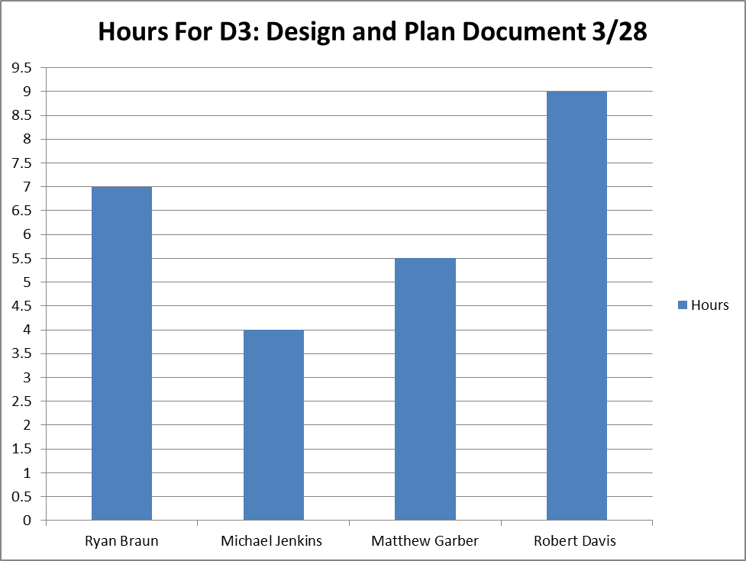

Individual Efforts

Michael
Open House - 5.75 hours
Document – 4 hours

Ryan
Unity Research - 6 hours
Group Meeting - 9.5 hours
Project Proposal - .25 hours
Scripting - 2.25 hours
Open House - 5.75 hours
Website - .5 hours
UML - .25 hours

Matthew
Group meeting - 9.5 hours
Survey Result - 1 hr
Open House - 5.75 hr
Unity Research - 1 hr
total: 17.25 hr
current doc time - 5.5 hr
Robert
Current Document 9 hours
Network UML Classes
Database Design
Architecture Description
Group Meetings 7 hours
Prototype Development 12 hours

